**WEB PROGRAMMING PROJECT ON**

**STUDENT RESULT MANAGEMENT SYSTEM.**

***PROJECTS ASSOCIATES***

Adithi K L.

BE-3rd year.

Dept of CSE.

NMAMIT.

***PROJECT GUIDE.***

Arun Rajpurohit.

Director.

DLithe Consultancy Services Pvt ltd.

**ABSTRACT**

The main objective of the project “STUDENT RESULT MANAGEMENT SYSTEM” is to provide the examination result to the student in a simple way. This project is useful for students and institutions for getting the results in simple manner. By a result analyser with subject status and marks is an application tool for displaying the results in secure way. The system is intended for the student. And the privileges that are provided to student are to read and execute his/here result by providing rollNo for secure login and in case of new student the registration is available. And the guest user has the privilege only to read. The whole result analyser will be under the control of the administrator and the admin as the full privileges to read, write and execute the result. And admin gives the privileges to student and the guest user to access the result. The student can share or download his/here result.

**ACKNOWLEDGEMENT**

DLithe Consultancy Services Private Limited, is EduTech company, based out in Bengaluru. Since its inception in the year 2018, the company is working with major academic institutions and corporate providing competency development services, technical consultation, and product development.  The company is lead by industry professionals with two decades of experience, leveraging their experiences towards student mentoring. Recently the company has also developed a mobile application for a health care company. The company has 20+ technical consultants who work on technical delivery and mentoring resources. The company vision is to build an agile workforce towards global industry needs. To support business entities to achieve customer experience and operational excellence goals. The company majorly works on full-stack development on Java, .Net, Python, Machine Learning, Cyber Security, Blockchain, Internet of Things, Flutter mobile application development technologies.    
The company has its presence in AIC, Nitte providing a facility for the student to work on product development, start-up culture.

**TABLE OF CONTENTS.**

**Sl.no Contents Page no.**

1. Abstract 2
2. Acknowledgement 3
3. Introduction. 5
4. Role of the Admin and Student. 6
5. Functional Requirements. 7
6. Languages used. 8
7. Screenshots. 9-18

i)MYSQL database. 9-10

ii)Home page. 11

iii)Admin page. 12-15

iv)Student page. 16-18

1. Conclusion. 19
2. References. 19

**INTRODUCTION.**

**What is Student Result Management System? Advantage & Disadvantage**

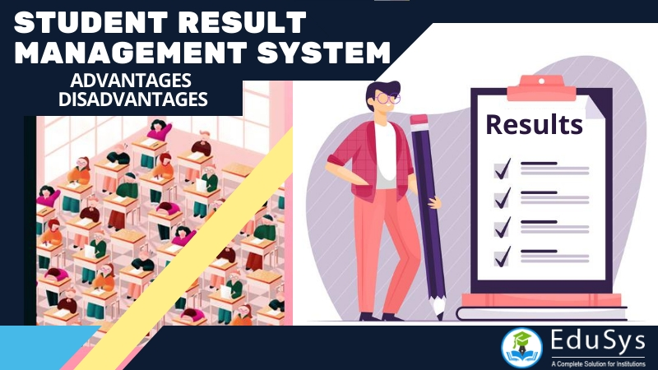

Student Result Management System is a technological opportunity for the school, college, university and coaching centre institutions searching for a secure, simple and alternative solution to the conventional paper-based exam results evaluation, reporting and distribution. Like any other software, the system comes with certain advantage and disadvantage.

The software application unbelievably unravels and quickens the result management system with unique templates by providing the administration a secure database system for storing, evaluating and publishing the test scores and grades of candidates online. The database likewise allows the students to observe and gander at the exam results on the web at whatever point necessary.

The software exhibits some effortlessness in solving, adjusting and eradicating the problems in traditional result and examination management with [automation system](https://www.edusys.co/blog/nba-naac-accreditation-college-software). One of the principal purposes of the system is to give the test results to the students in the as fundamental and exact way as possible. The administrator, teacher, professors, and staff can likewise modify and assess marks for the students whenever needed.

Advantage and Disadvantage of Student Result Management System

While looking for the advantage and disadvantage of the student result management system and the ways on how to create an effective exam result system and database, it is essential to note that it is possible to design the software in HTML or by using PHP & Bootstrap. Few open source codes are available for free download on the internet, too.

**FEATURES:**

* Home page – A brief introduction about the college, courses offered ,history of the college and address.
* Login page for Admin.
* Login page of Students.

**ROLE OF THE ADMIN AND STUDENT:**

ADMIN:

The admin is responsible for uploading the marks obtained. He can add the subject marks and make any kind of modifications like storing, updating, deleting.

STUDENT:

Student must be an authenticated user of the college to access this application. The student can view the semester marks and individual subject marks . The student can also make a comparative analysis with the results generated.

PRACTICES:

· Storing and retrieving the unorganized data.

· Segregating the data based on a particular register no(rollNo).

**FUNCTIONAL REQUIREMENTS:**

*FUNCTIONALITIES OF THE ADMINISTRATOR*:

Administrator plays a main role in this project. Once administrator enters the valid user id and password he/she will be provided with the following services.

* Uploading marks.
* Add subjects and upload student details.
* Update the student’s database.

Admin can add Subject details and also add student details.

Update the student’s database:

This privilege enables the administrator to update his/ her details.

*FUNCTIONALITIES OF THE STUDENT:*

Login:

Once applicant enters the valid register no(rollNo) he/she will be provided with the following services.

* Viewing semester marks.
* Viewing subject wise marks.
* Logout.

On clicking the respective options we navigate to respective pages.

Viewing semester marks:

This privilege enables the student to viewing semester marks.

Viewing subject wise marks:

This privilege enables the student to viewing subject wise marks.

Logout:

This service makes the student to logout from his/her account.

**LANGUAGES USED:**

JAVA: **Java** is class based, [object-oriented](https://en.wikipedia.org/wiki/Object-oriented_programming) [programming language](https://en.wikipedia.org/wiki/Programming_language) that is designed to have as few implementation [dependencies](https://en.wikipedia.org/wiki/Dependency_(computer_science)) as possible. It is a [general-purpose](https://en.wikipedia.org/wiki/General-purpose_language) programming language intended to let [application developers](https://en.wikipedia.org/wiki/Application_developer) write once, run anywhere.

HTML: HyperText Markup Language

HyperText Markup Language (**HTML**) is the set of markup symbols or codes inserted into a file intended for display on the Internet. The markup tells web browsers how to display a web page's words and images.

## CSS: Cascading Style Sheets

CSS stands for Cascading Style Sheets. It describes how Html elements should be displayed on screen. It is a powerful tool for web designers to change the design and control over web pages that how it should be displayed. It is supported by all browsers and is designed primarily to separate the document content from document presentation.

It was developed by W3C (World Wide Web Consortium) in 1996. Term cascading in CSS implies the fact that you can apply multiple style sheets to a single web page. Extension used to save CSS files is ".css".

JavaScript:

**JavaScript** is a fun and flexible programming language. It's one of the core technologies of web development and can be used on both the front-end and the back-end.

**This following project is executed using JSP, Eclipse IDE, Tomcat Server, MYSQL Database.**

**SCREENSHOTS:**

1.MYSQL database creation in the MYSQL command line prompt:

i)Creating the database called ***results5*** ,next create the table called ***student5*** with the attributes like course, branch, rollNo(primary key), name, fatherName and gender. create a table called ***result5*** with the attributes rollNo,s1,s2,s3,s4,s5,s6,s7 for the respectively subjects.

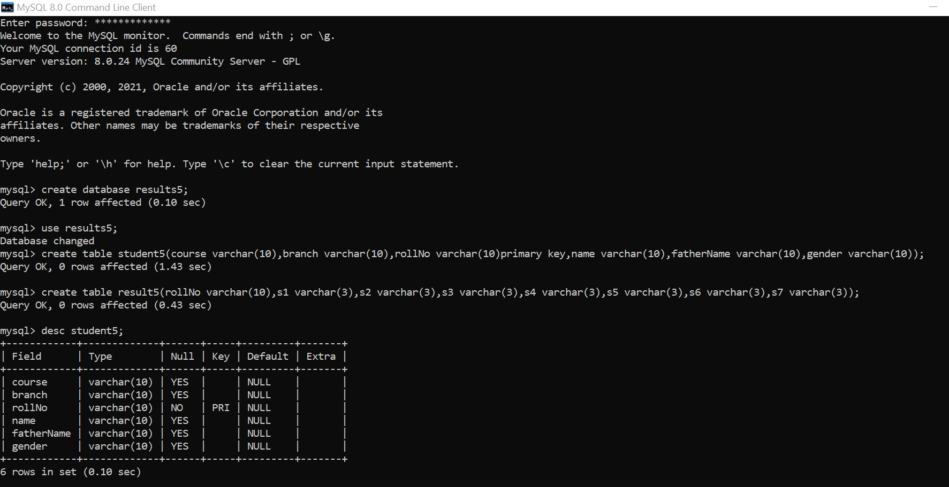

ii)The contains of the table are displayed using the command ***desc   
_table-name_;***

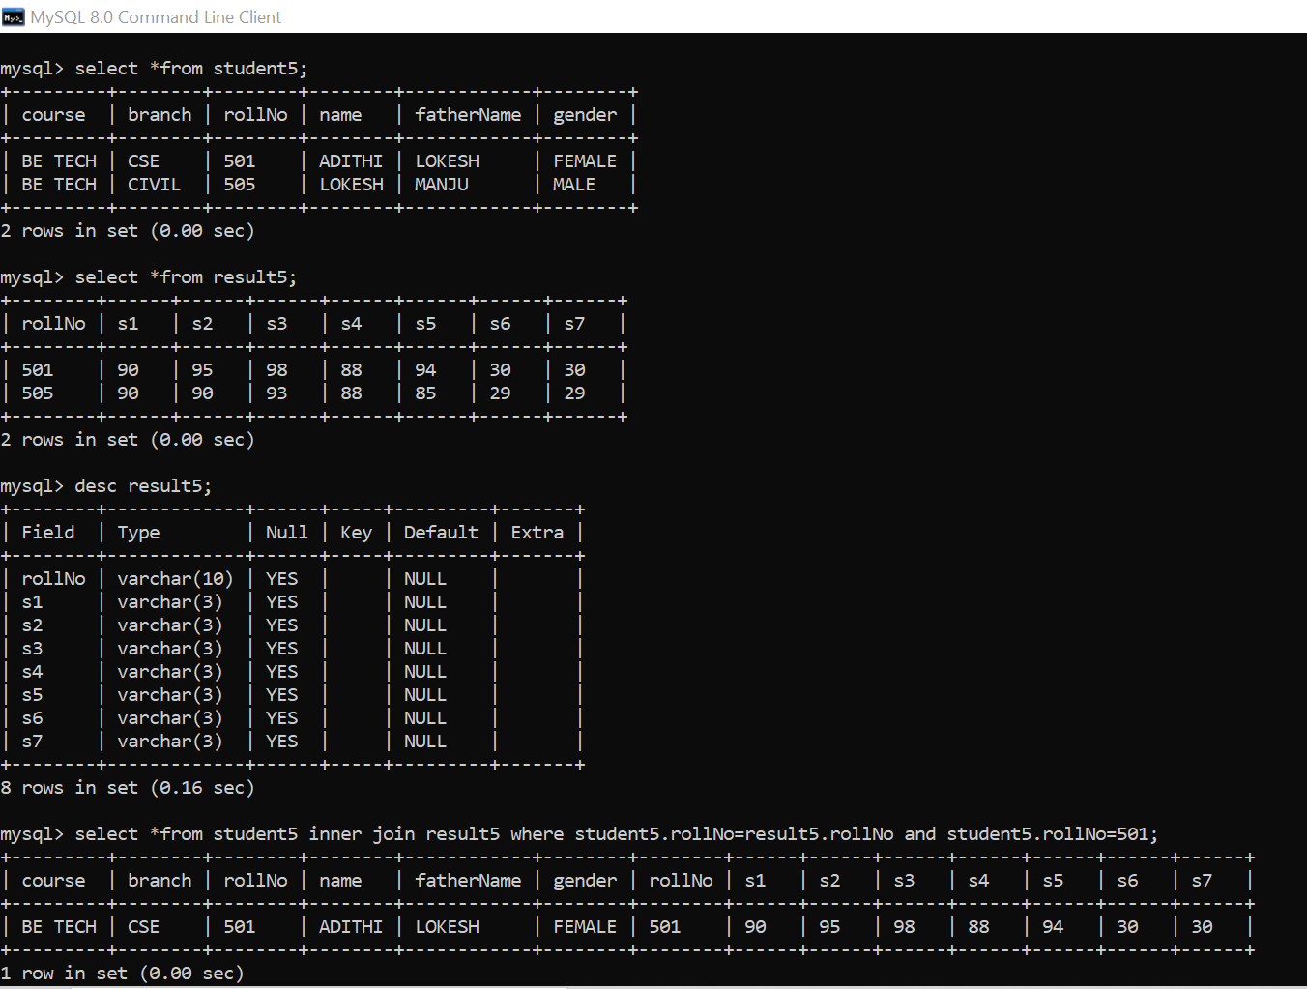

The queries of selecting the student’s details using the rollNo:

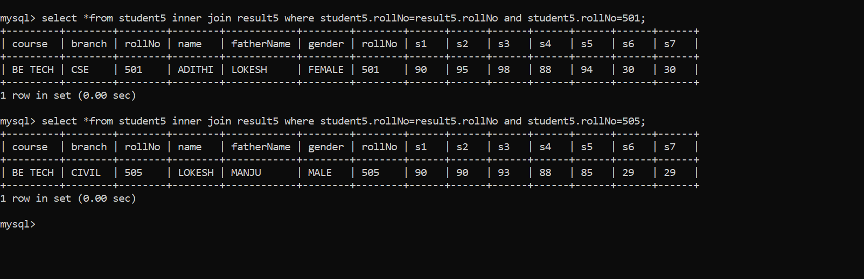

2.Home page:

The brief information of the college is given.

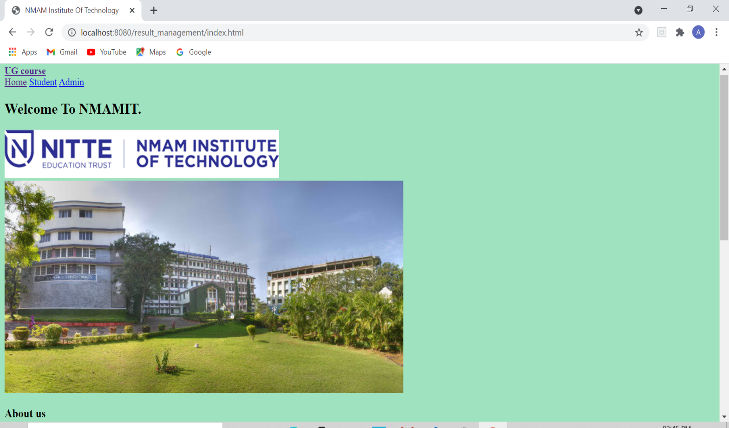

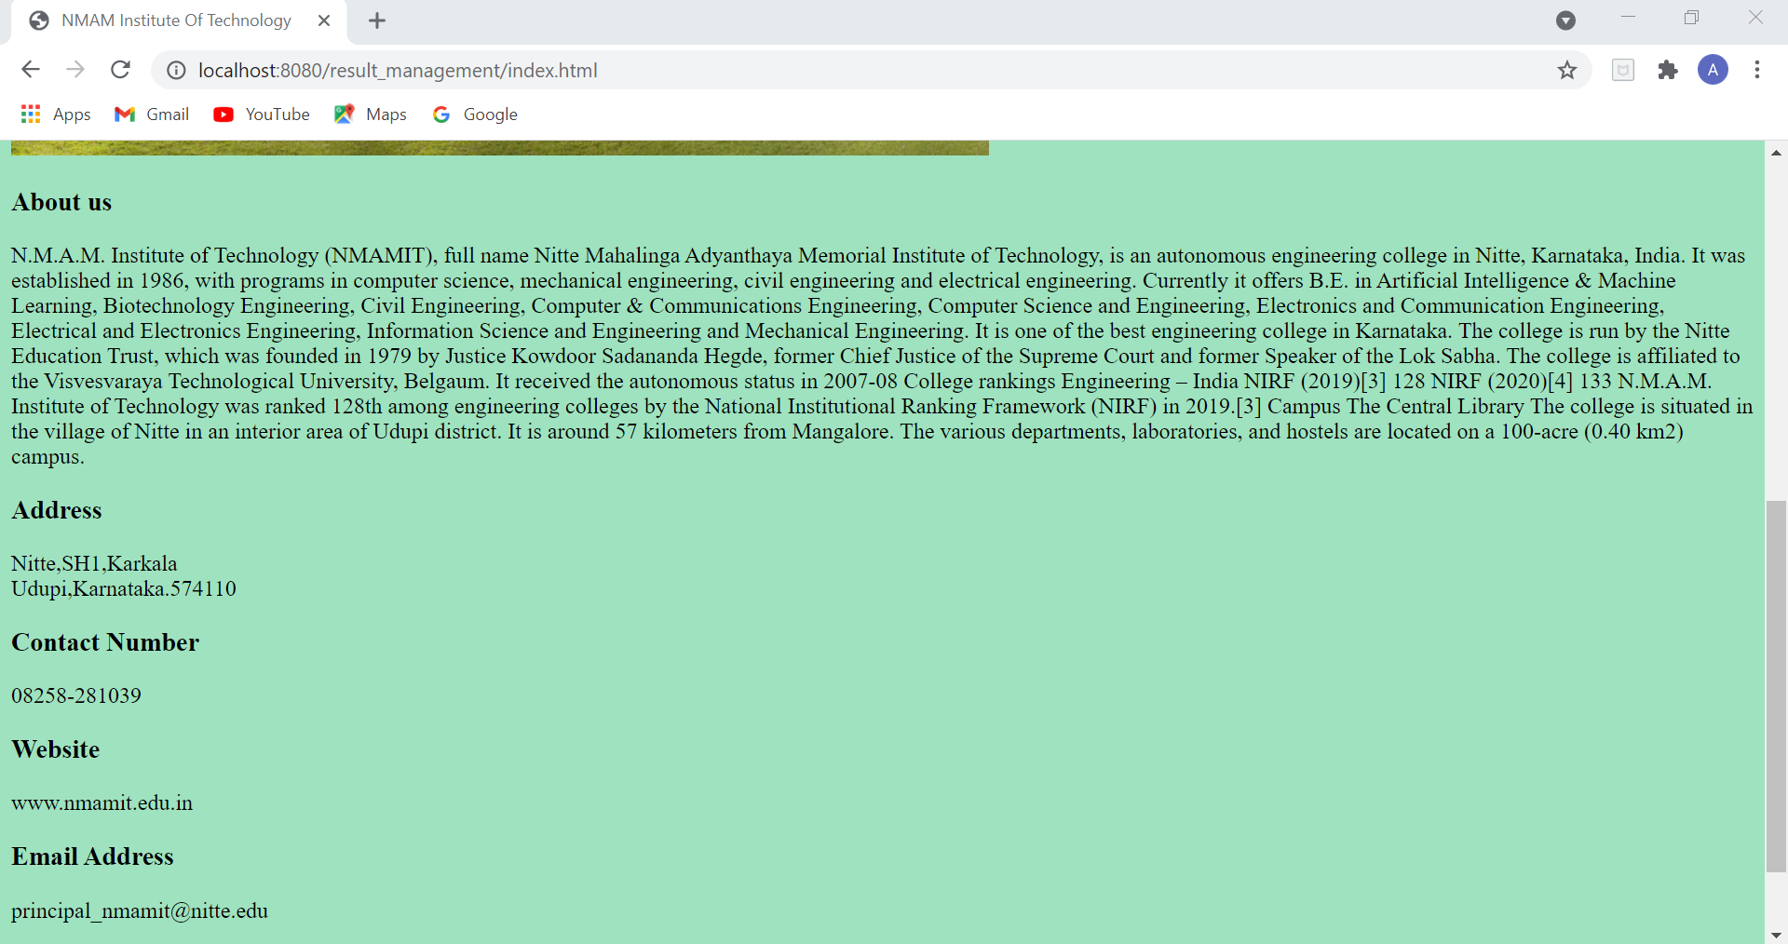

3.Admin Login Page:

i)The login page of the Admin shown.

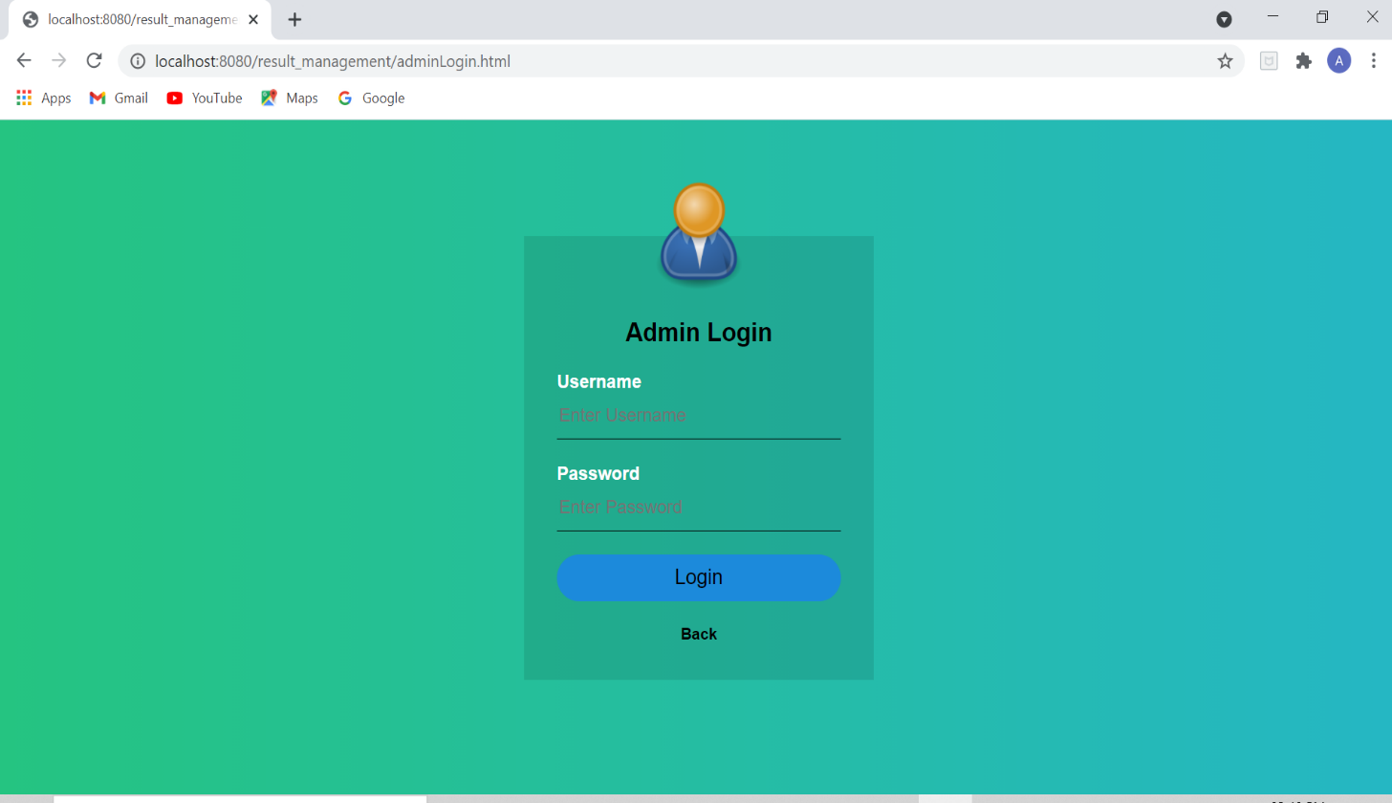

ii)Admin entering the correct password and the user name.

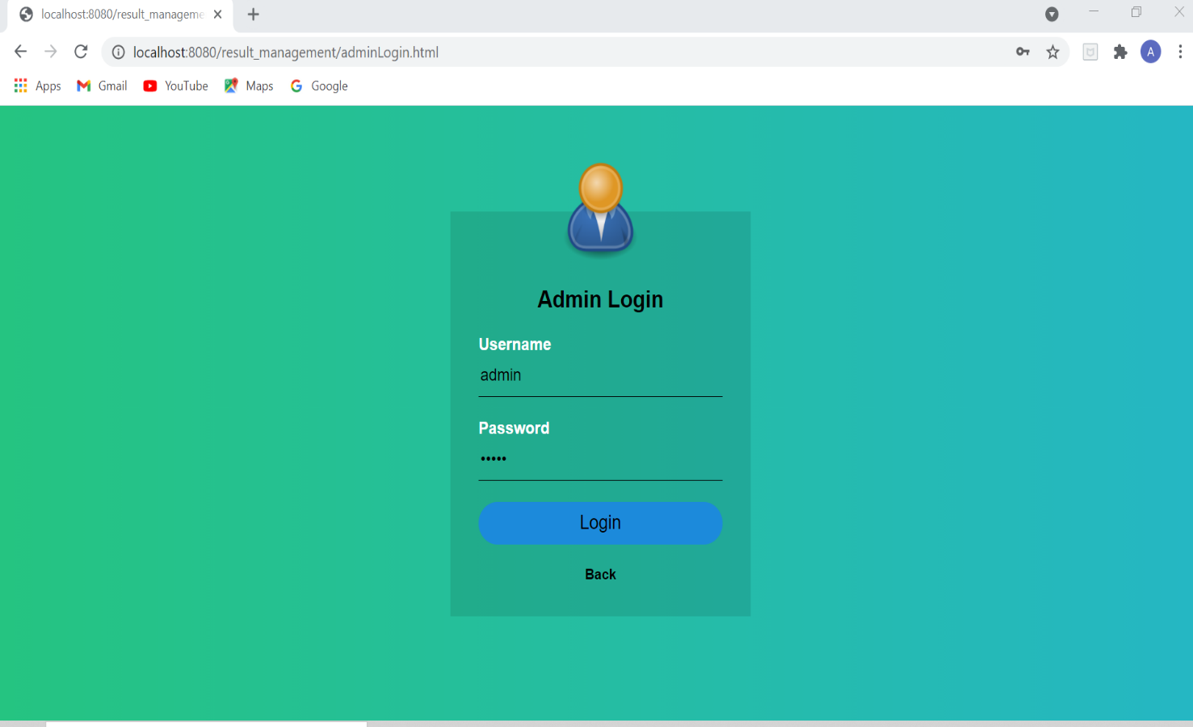

iii)Admin entering the incorrect password and username.

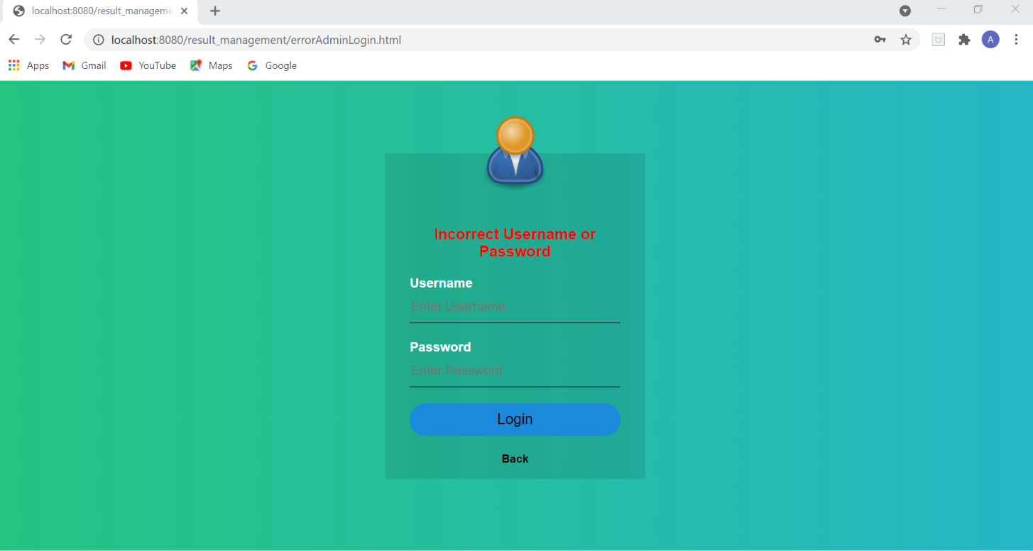

4.Admin entering the student’s details:

i)Adding the new student.

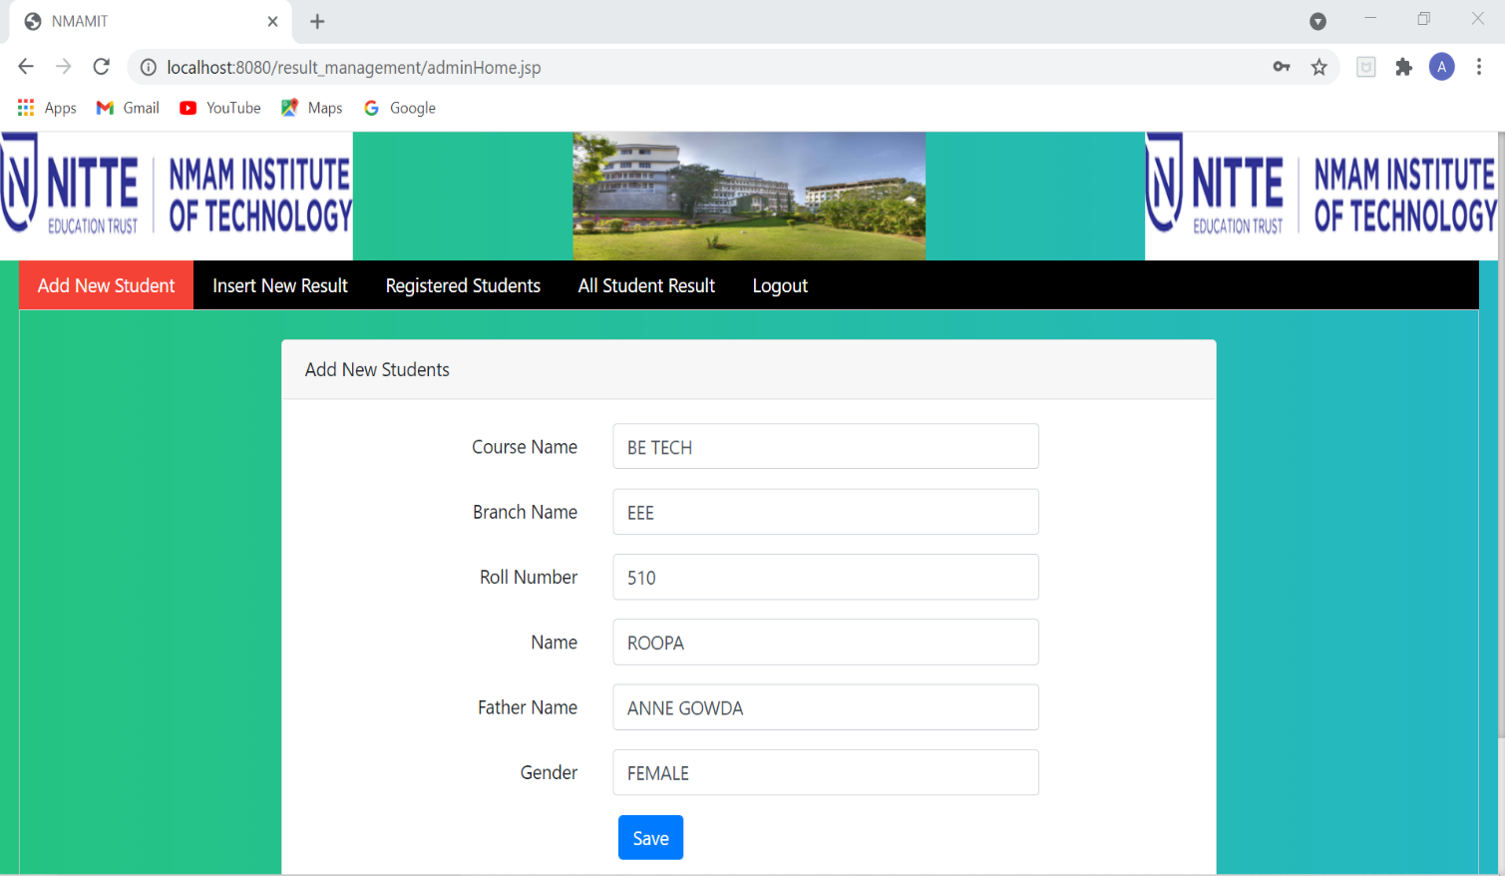

ii) Entering the student’s marks subject wise.

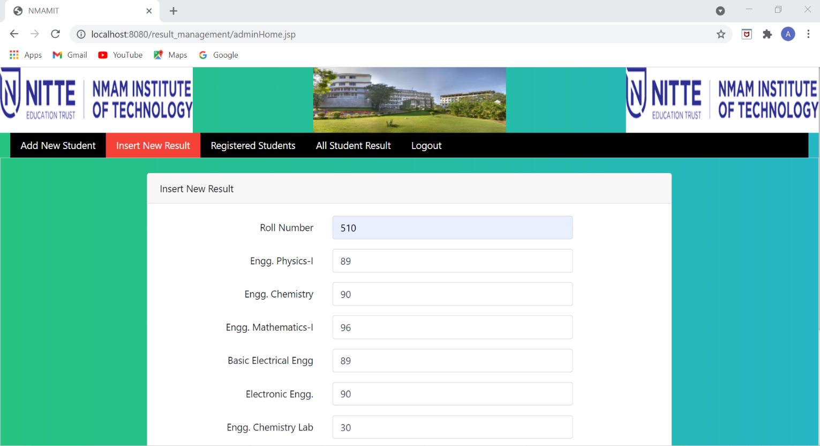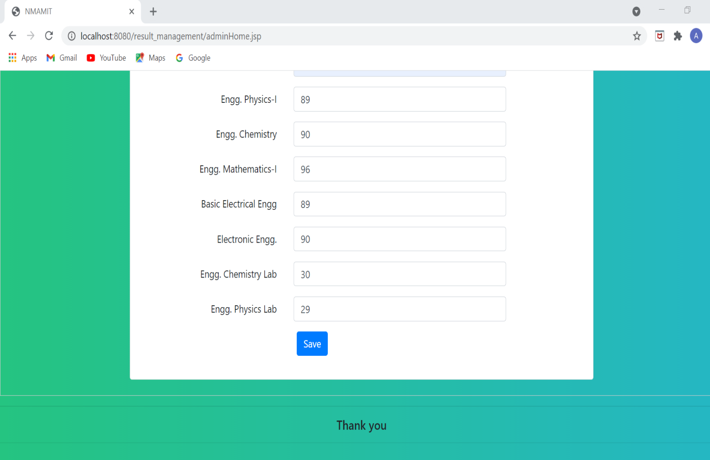

iii) Registered students list.

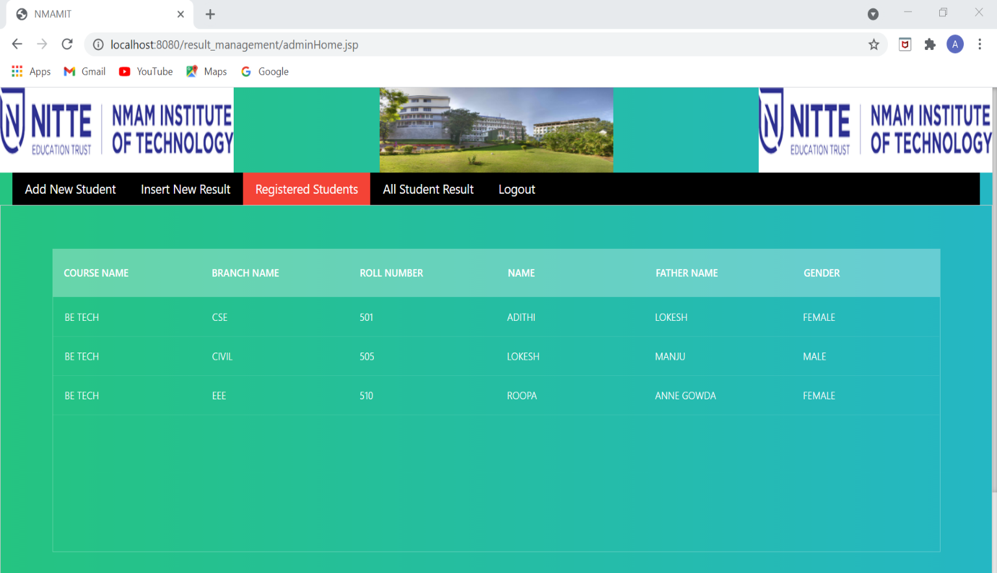

iv) All students marks list based on their respective rollNo.

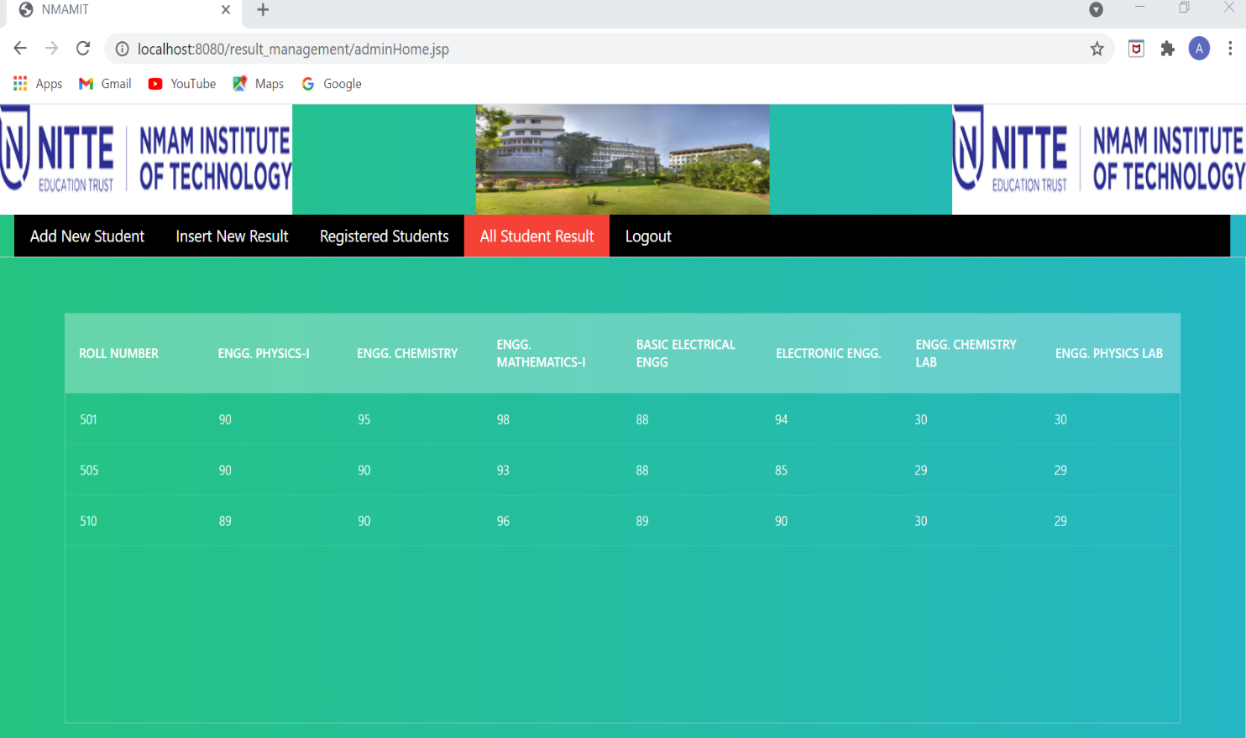

4.Student’s Login Page:

i) Front login page.

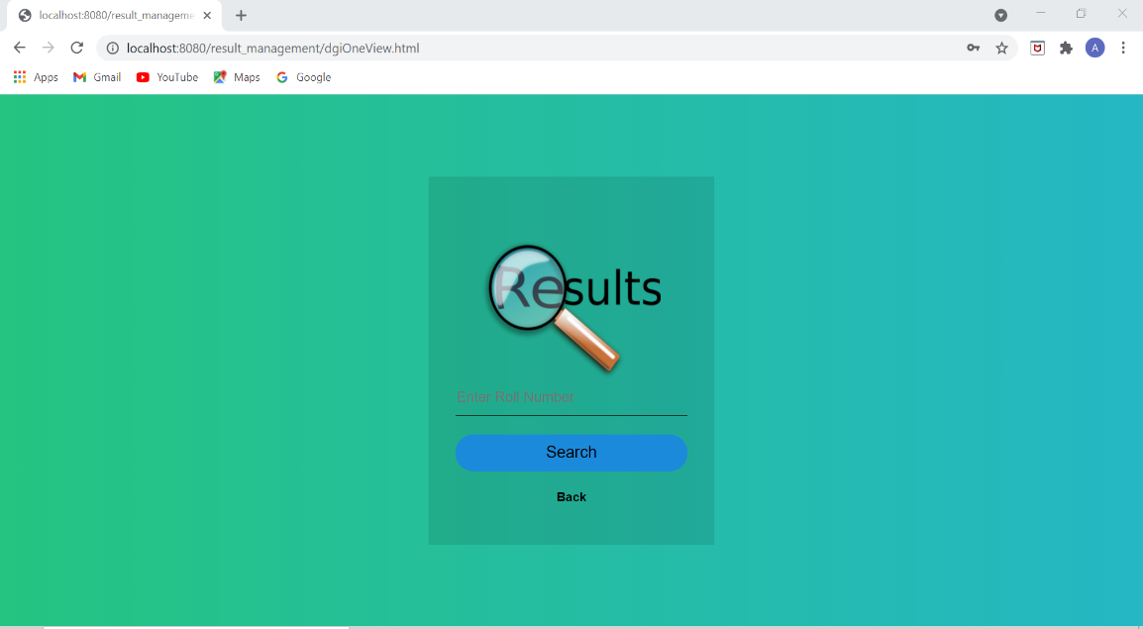

ii) Student entering the incorrect rollNo.

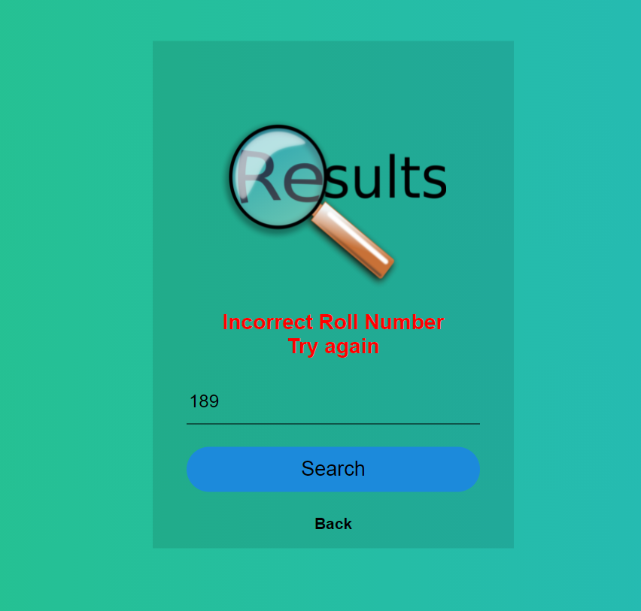

iii) Student when entered the correct password, you will get the marks card.

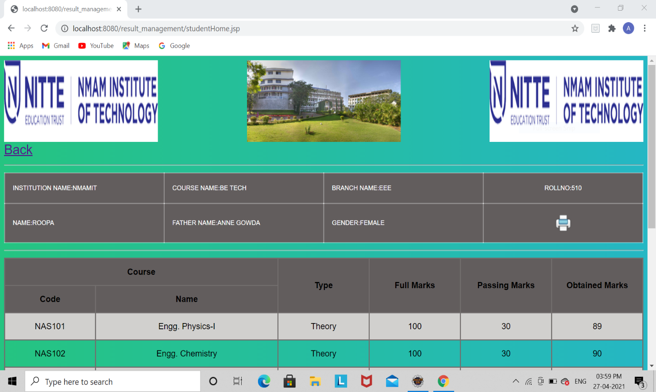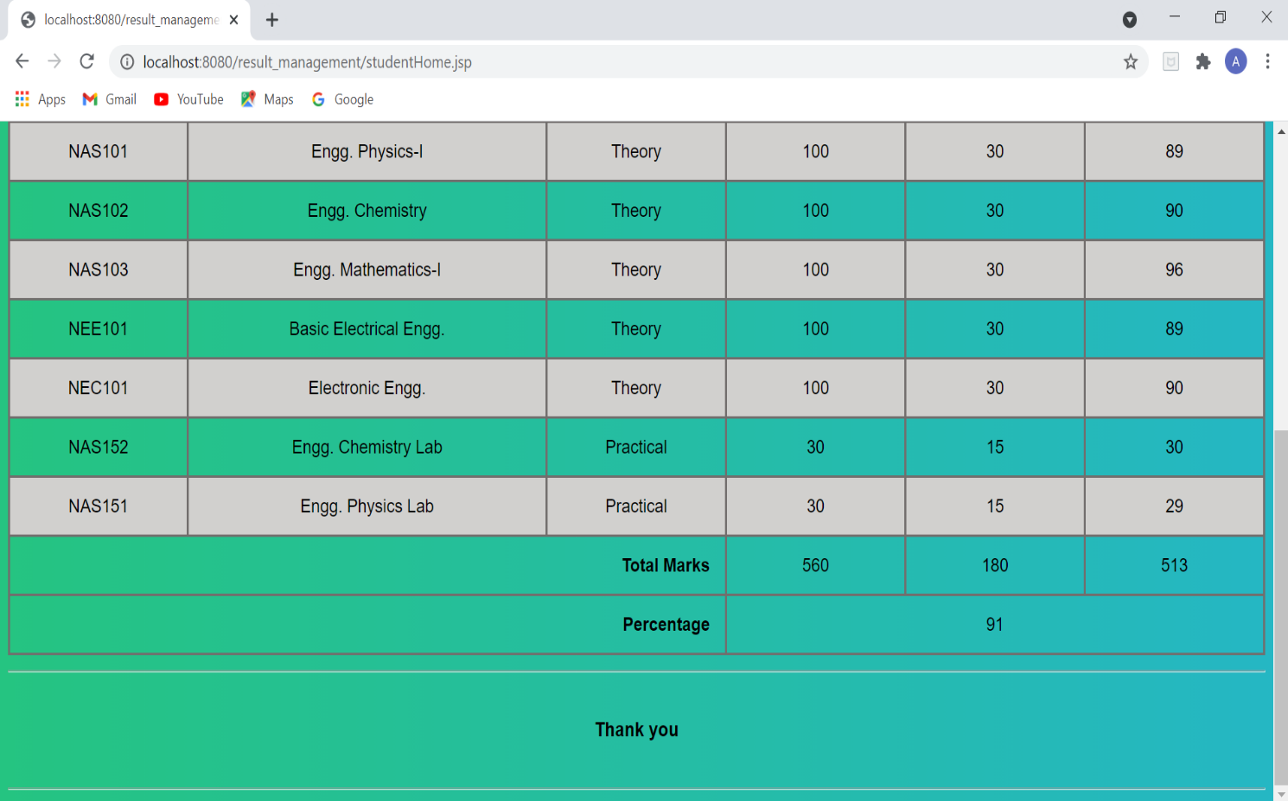

4.Atlast we will able to download the marks card or take print out:

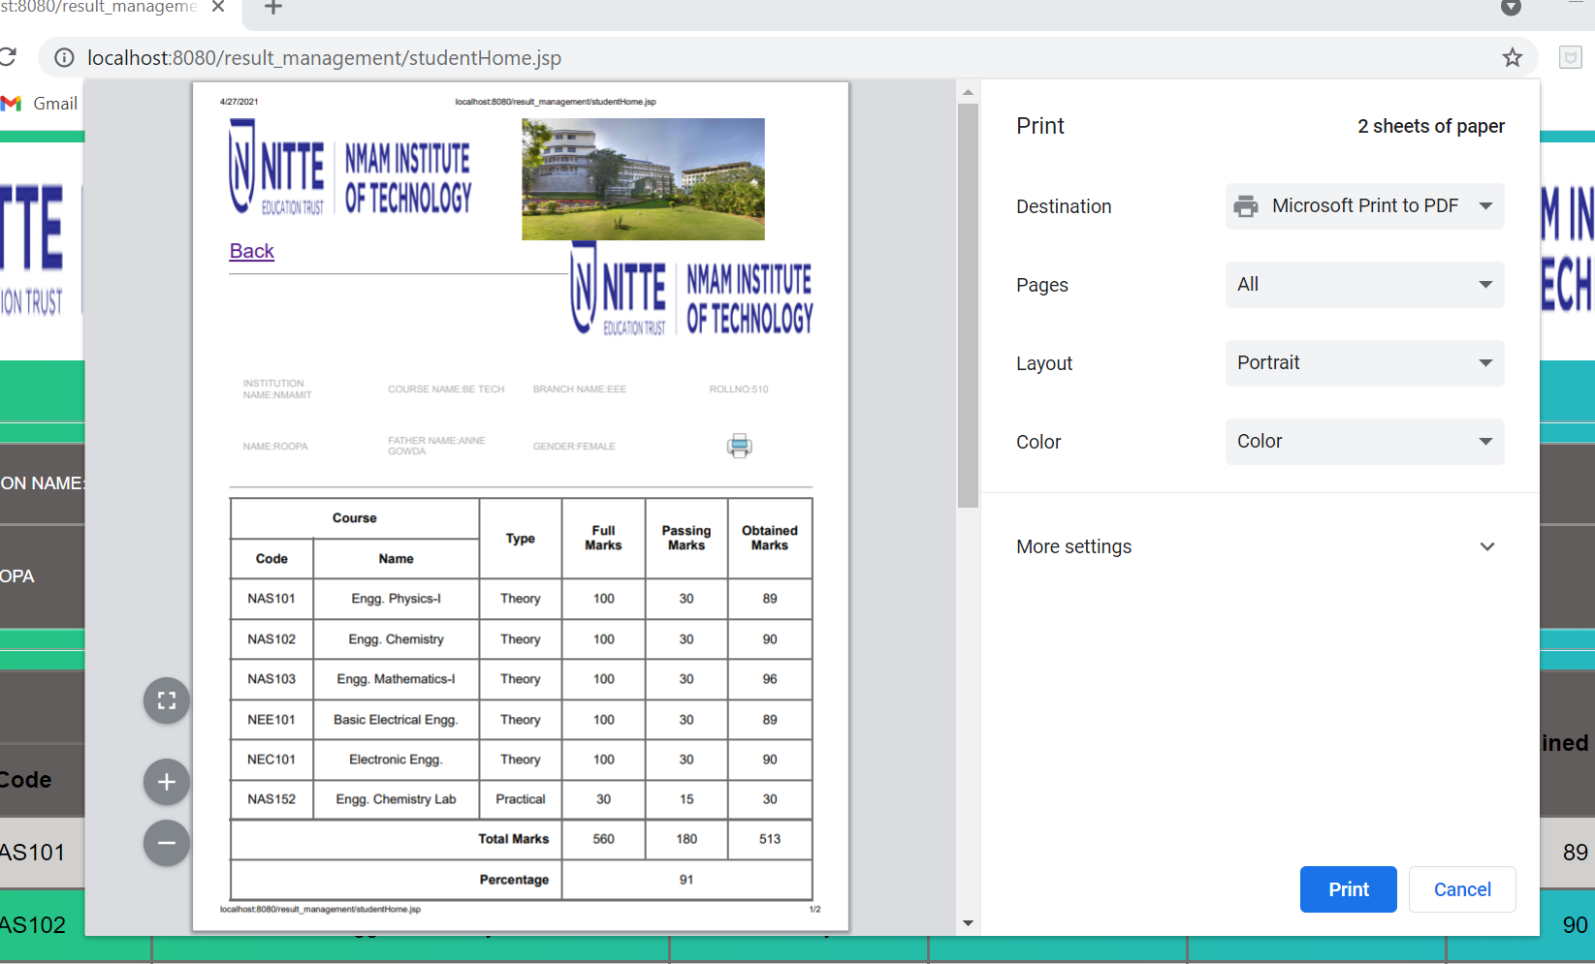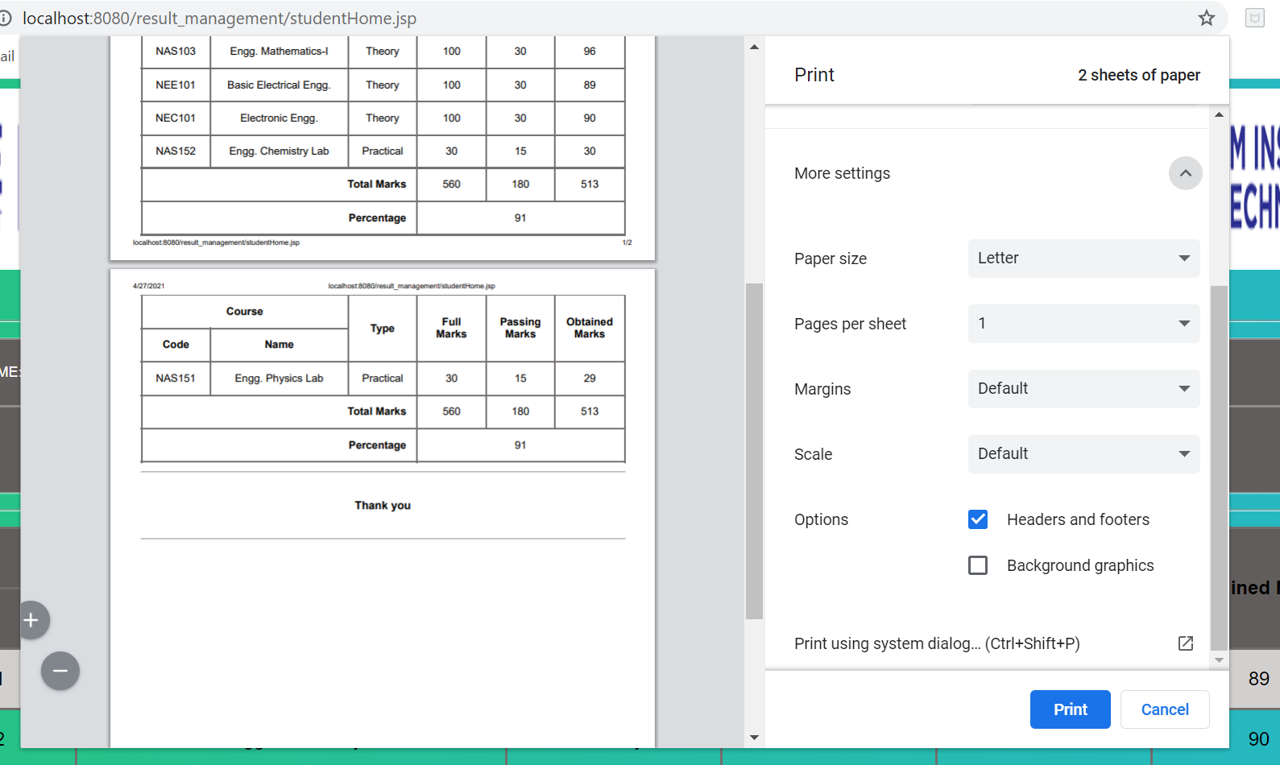

**CONCLUSION**

The goal of the system is achieved and difficulties are solved. The project is built such that it is user friendly. Analysis of the scoring system it shows by the result of individual subject and final result also displayed in the percentage .Depending on its range of marks. The project can be easily used in college for college result analysis of student. It reduces time which required for manual calculation. This system helps to calculate result fast so it optimizes the manpower.

**REFERENCES:**

* [www.wikipedia.com](http://www.wikipedia.com)
* [www.youtube.com](http://www.youtube.com)